Setup MATLAB Engine for Python/Jupyter

Step 1 Identify the installation folder by running command below in MATLAB command window
cd (fullfile(matlabroot,'extern','engines','python'))
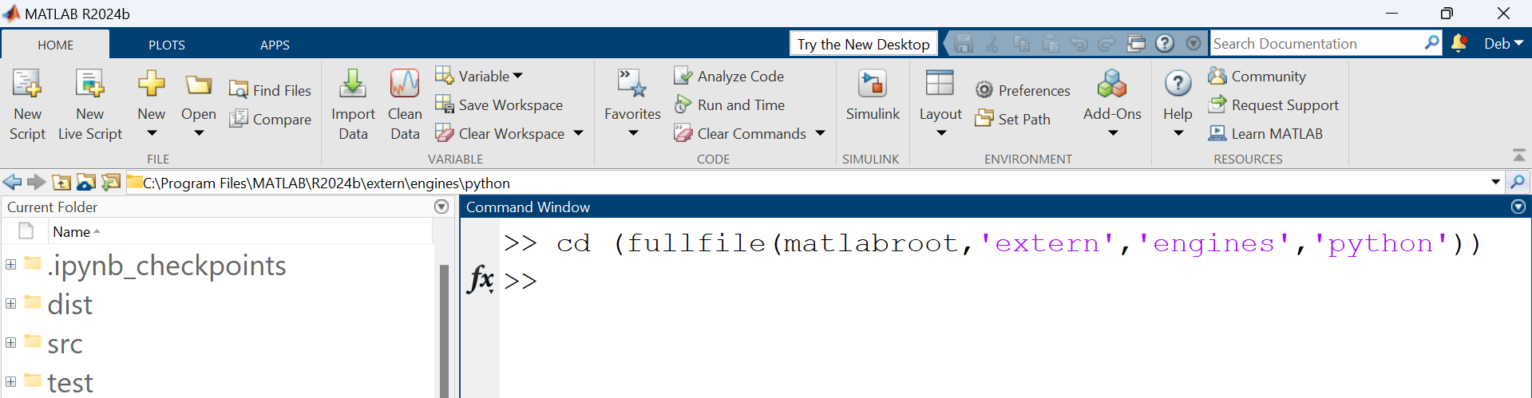
Copy the directory which comes up when the command is executed as highlighted in red in the image above
Step 2 Open command line in administrator mode and change to the directory copied in earlier step
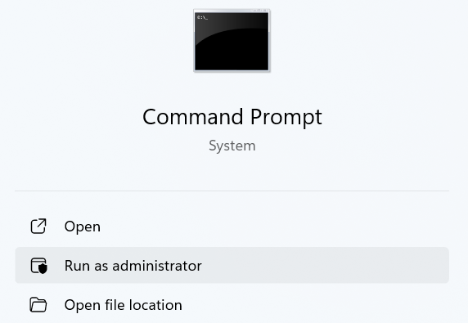
cd C:\Program Files\MATLAB\R2024b\extern\engines\python
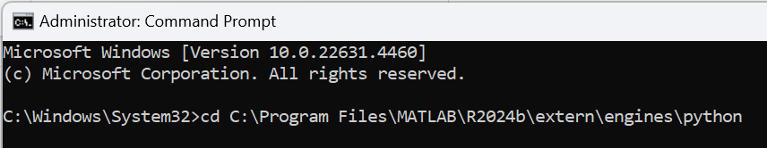
Now run the following command from the command line. The MATLAB engine corresponds to installed MATLAB version (24.2.1 for 2024b). For a different version of installed MATLAB, the engine version can be found in the version branch (GitHub - mathworks/matlab-engine-for-python)
python -m pip install matlabengine==24.2.1
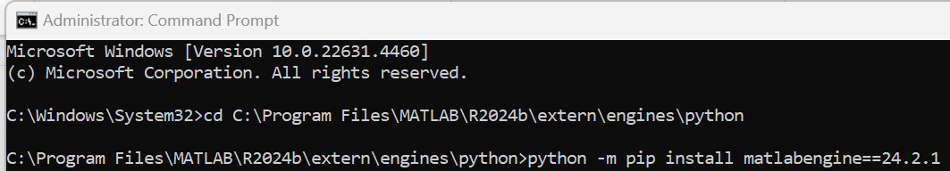
Also, install the following libraries by running following commands from command line
python -m pip install notebook
pip install jupyter-matlab-proxy

Step 3 Open Jupyter notebook by typing the same in command form from the command line
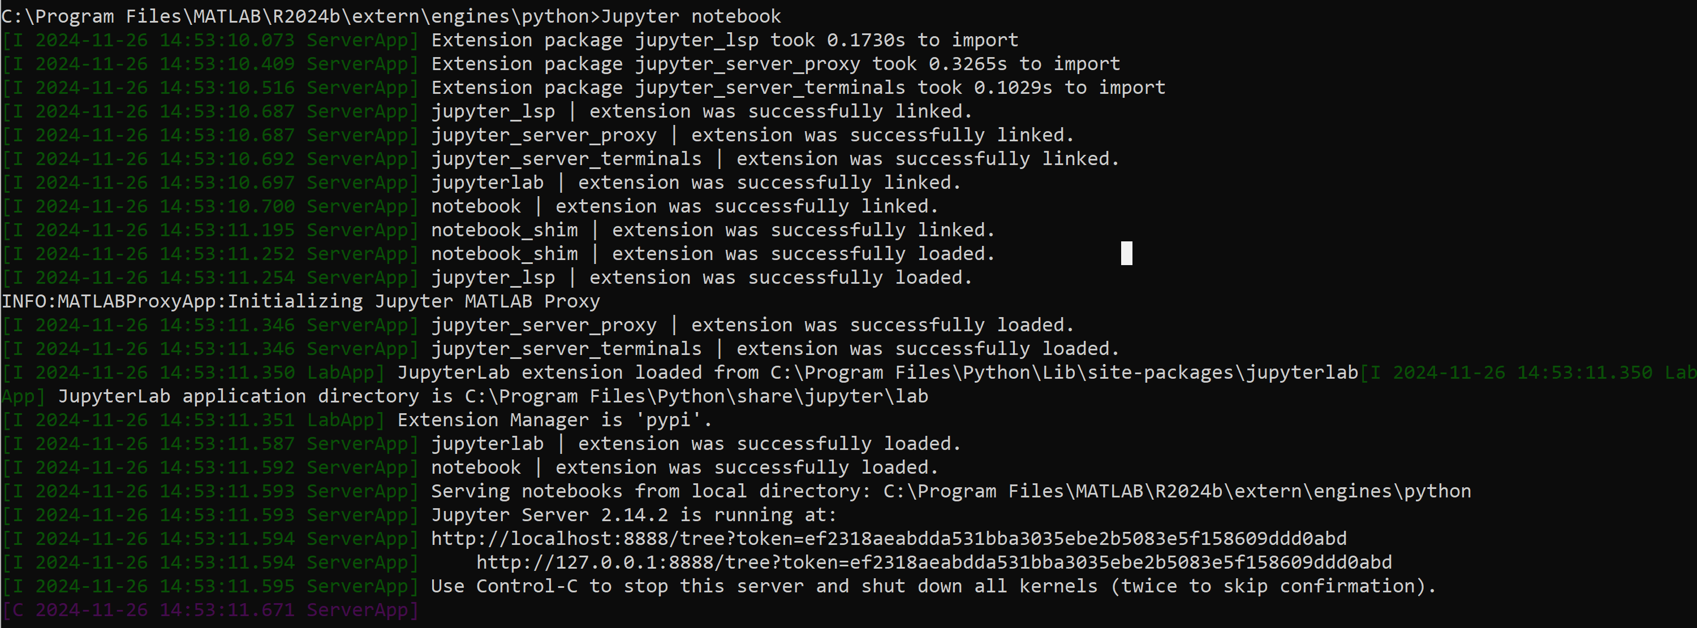

We can open any of the local servers from our browser to open Jupyter. Start MATLAB Engine if using ipykernel.
